# Being a Power House – The Value of Empathy

Illustrations

Related Documents

**Description:** Suggestions on how to apply empathy when speaking with the member.

|  |
| --- |
| Illustrations |

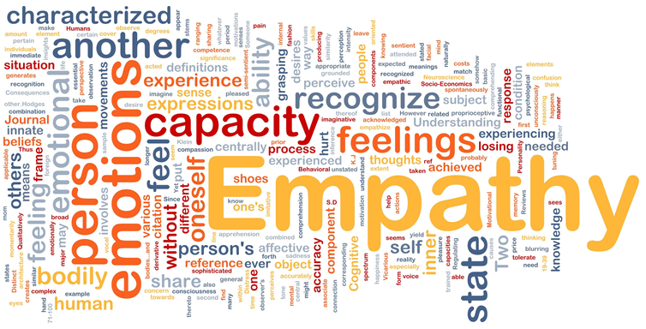

Empathy is the ability to set aside your understanding and perspective of a situation and **listen** to the caller from **their** perspective. Listen first, understand the member’s perspective without trying to **solve** the issue as you perceive it. Express that empathy, and only **then** proceed to resolving their concerns.

“The biggest communication problem is we do not listen to understand. We listen to reply.” -Steven R. Covey

Each caller is a **person** with their own worries, fears, and stress factors. Every caller may be dealing with a range of situations, and it is the representative’s job to acknowledge the member and treat each person professionally, with **respect** and **empathy**.

#### When does Empathy come into play?

When a member is displaying negative emotions (whether it be anger, sadness, frustration, confusion, or any other negative feeling) representatives should react in a positive and caring manner. For example, CCRs should be empathetic:

#### When a member calls in about a death in the family

#### When a member calls about a sick child’s medication

#### When a member calls in frustrated with the situation at hand

#### Why should I be Empathetic?

#### Representatives and companies build trust with their customers by helping members feel valued. When members trust our business, the company gets stronger. This is a “win-win” for both the member and the company, because:

#### Personal care and concern help members feel that they are valued

#### Satisfied members are important to strengthening our business

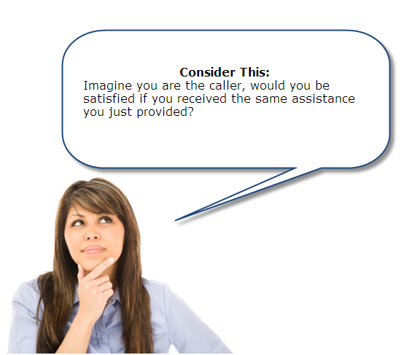

#### How can I be more Empathetic?

#### Be patient

#### Give the caller time to speak openly about their situation

#### Allow the caller to express their situation at their pace

* + Actively listen, then speak when the caller pauses

#### Trust the caller understands what you are saying (but use common language)

#### Be a good listener

#### Pay attention to the caller’s tone and how fast or slowly they are speaking

#### Pay attention to Non-verbal cues (long pauses, sniffles, huffs, etcetera)

* Take notes as the caller is speaking so you can address all areas of concern before the call ends

#### Acknowledge

#### Show that you understand the caller’s needs and feelings

#### Paraphrase the caller’s concerns

#### Be sincere

#### How do I convey empathy?

#### “I’m sorry for your loss and I realize this is a very difficult time for you right now, I’ll be very happy to assist you in any way possible.”

#### “I absolutely understand the importance of your child’s needs, let me see what I can do for you right now”

#### “I completely understand your frustration and how this inconvenience affects you, I can help you by…”

Top of the Document

|  |
| --- |
| Related Documents |

[Being a Power House - Improving the Member Experience with Empathy (008976)](https://thesource.cvshealth.com/nuxeo/thesource/" \l "!/view?docid=6d367d72-7134-4553-a452-a453e10091e9)

[Customer Care Power House Index (008982)](https://thesource.cvshealth.com/nuxeo/thesource/#!/view?docid=7b0390db-a2ed-4307-b9c5-b842130225e9)

[Customer Care Abbreviations, Definitions and Terms Index (017428)](https://thesource.cvshealth.com/nuxeo/thesource/" \l "!/view?docid=c1f1028b-e42c-4b4f-a4cf-cc0b42c91606)

#### Top of the Document

Not to Be Reproduced or Disclosed to Others without Prior Written Approval

**ELECTRONIC DATA = OFFICIAL VERSION / PAPER COPY = INFORMATIONAL ONLY**